**Title: Interacting foundation species hypothesis: how genetics-based interactions affect community diversity, stability and network structure.**

**Authors:** Arthur R. Keith1,3, Joseph K. Bailey5, Matthew K. Lau1,6,Thomas G. Whitham1,2,4

*1Department of Biological Sciences, Northern Arizona University, Flagstaff, AZ 86011, U.S.A.*

*2Merriam-Powell Center for Environmental Research, Northern Arizona University, Flagstaff, AZ 86011, U.S.A.*

*3E-mail: Arthur.Keith@nau.edu*

*4E-mail:Thomas.Whitham@nau.edu*

*5Department of Ecology and EvolutionaryBiology, The University of Tennessee, Knoxville TN 37996*

*6E-mail: Matthew.Lau@nau.edu*

**Running Title:Genetics-based Interacting Foundation Species Hypothesis**

**Keywords:** Community Stability, Foundation Species Hypothesis, Community Genetics, *Populus angustifolia*, *Pemphigus betae*, Diversity-Stability, Emergent Properties, Arthropod Community

**Type of Article:** Letter

**Number of Words in Abstract/Manuscript:**150max./5000max.

**Number of References:**50max.

**Number of Figures and Tables:**6 max.

**Corresponding Author Information:** Arthur R. Keith, Department of Biological Sciences, Northern Arizona University, PO Box 5640, Flagstaff, AZ. 86011. Phone: 928-523-5970, Fax: 928-523-7500, E-mail: Arthur.Keith@nau.edu

**Abstract:**

We examined the hypothesis that genetic-based interactions between foundation species plays an important role in defining complex community traits such as diversity, stability, and species interaction networks. In a two year experimental manipulation of the tree (*Populus angustifolia*) and its herbivore (*Pemphigus betae*), we found that the interactions of these two foundation species defined: 1. arthropod community composition, 2. arthropod community diversity (Shannon’s H’), 3.the stability of arthropod communities through time (Bray-Curtis similarity), and 4. the structure of species co-occurrence networks. Network structure of individual plant genotypes was also a significant predictor of arthropod community diversity and stability. These findings represent an important step in evaluating evolution in a community context and they suggest that perturbations such as climate change that affect the interactions of foundation species are likely to create destabilizing conditions on their associated communities.

**Introduction:**

It is widely accepted that individual species differ in their interaction strengths and their influence on other community members. Foundation species represent the epitome of strong interactors and they are defined as those that structure a community by creating locally stable conditions for other species, and by modulating and stabilizing fundamental ecosystem processes (Dayton, 1972). In their review, Ellison et al. (2005) argued that foundation species are synonymous with keystone species, ecosystem engineers, dominant and other similar terms (Grime 1984, Hollings 1992, Jones et al. 1994, Houston et al. 1994, etc). Importantly, all of these terms refer to species of large effect, such that their loss from an ecosystem would have significant effects on other species and ecosystem processes. While many studies have demonstrated the effects of foundation species on their associated communities and ecosystem processes, this fundamental concept raises many key issues of ecological, evolutionary and conservation importance. For example, how many foundation species does an ecosystem have, how do the interactions of multiple foundation species affect community diversity and stability, and are the interactions of foundation species genetically-based such that whole communities may ecologically and evolutionarily change in response to the evolution occurring among interacting foundation species? Such questions become especially important when considering the challenges of climate change, habitat fragmentation, invasive exotics on native ecosystems and the need to restore habitats in a way that supports high levels of biodiversity and ecosystem function (refs).

To address these questions, it is critical to understand how genetic variation in foundation species affects other community members and how genetics-based interactions of multiple foundation species can potentially drive an associated community. Because many plant traits are, in part, genetically based (e.g., architecture, morphology, chemistry, phenology, ontogeny), together these traits can result in a multivariate phenotype (Holeski et al. 2012) that is associated with extensive intraspecific genotypic and phenotypic variation. In response to such variation, whole communities of organisms ranging from plants to microbes, insects and vertebrates from around the world have exhibited sorting at the individual plant genotype level (review by Whitham et al. 2012). These genotypic effects can be so consistent and long-lasting that individual herbivores can become locally adapted to individual plant genotypes (other refs; Evans et al. 2008, 2012). This community specificity to individual plant genotypes raises the potential for the interactions between highly interactive foundation species to define a much larger community of organisms. For example Mooney and Agrawal (2008) showed plant genotype affects ant-aphid interactions with implications on community structure and more recently Keith et al. (2010) proposed a genetics-based Interacting Foundation Species Hypothesis (IFS) in which the genetics-based interactions of two or more foundation species defined a much larger community. Although these studies lacked the critical experiments to confirm or falsify this hypothesis, here, we present findings from new common garden experiments designed to address this hypothesis and discuss their general implications.

Cottonwoods are foundation riparian tree species in the American west (Eckenwalder1997, Whitham et al. 2010) that are the focus of much conservation due to climate change and loss of habitat to invasive exotics (Friedman et al. 2005, Grady et al. 2011) and the large number of species that are dependent upon them for their survival (e.g., Bangert et al. 2013). Genetic variation within *Populus* spp has been shown to be strongly linked to ecosystem function and diversity (Schweitzer et al. 2012). Because the abundance and distribution of a common insect herbivore, the galling aphid (*Pemphigus betae*), is strongly determined by the resistance and susceptibility traits of its host tree, *P. angustifolia*, which in turn affects many other community members (Dickson and Whitham 1997, Bailey et al. 2006, Compson et al. 2011, Smith et al. 2011). Due to its role in the structuring and stabilizing of the associated community (Dickson and Whitham 1997, Keith et al. 2010), the aphid may also be considered a foundation species or species of large effect. Here, we examine how the genetics-based aphid-tree interactions can affect the diversity, stability and network interactions of a large associated arthropod community.

To test IFS, we used resistant and susceptible replicates of 10 different individual tree genotypes in a common garden. We experimentally removed aphid and examined several arthropod community traits such as arthropod abundance, species richness and Shannon’s diversity index across a two year period. We also examined more complex traits like stability as defined by Bray-Curtis similarity and community network structure using co-occurrence analysis. We predicted that if community stability was related to tree genotype and susceptibility to the aphid (Keith 2010), the community network structure of interacting species would also respond to our treatment. In other words, the exclusion of a foundation herbivore would not only affect community composition, richness, abundance and stability, but also the network of co-occurring species and these traits would be genotype dependent. Our results show that tree genotype, community richness and network structure can be used as predictors of arthropod community stability across years. These findings confirmed our hypotheses that genetic based interactions of foundation species can define complex properties of associated communities.

**Materials and Methods:**

***Experimental Garden Studies:*** Because previous studies had shown differences in community composition and stability in aphid resistant and susceptible tree genotypes, we designed an aphid exclusion experiment using replicated tree genotypes in a common-garden. Common-gardens allowed controlling for plant genotype while also minimizing environmental variation. The common gardens used are 16-yrs-old and located at the Ogden Nature Center in Ogden, Utah. The gardens contain replicated genotypes of *Populus angustifolia* trees collected from along the nearby Weber River. Trees were planted in a random arrangement to minimize the possibility for auto-spatial correlation. This cottonwood is a dominant of riparian habitats and is widely distributed throughout the Rocky Mountains of the United States and southern Canada (Eckenwalder 1984).

***Aphid exclusion treatment:*** The lifecycle of *Pemphigus betae* allowed for a simple method to intercept gall creating aphid stem mothers en route during their spring migration from the base of the tree up toward awaiting leaf buds. Tangle-Trap insect trap coating was used to exclude aphid stem mothers on treatment branches. An approximately 1/2” thick by 1” wide coating was applied around the base of each treatment branch to prevent stem mothers from reaching sites for gall initiation. Very few aphids are able to circumvent this method of prevention so treatment effect is usually high (**Fig 1**).

***Arthropod Sampling:*** Arthropods were visually censused using the methods of Keith et al. (2010). Equal diameter branches were selected to standardize for leaf area (Fischer et al. 2004) and chosen to be in a north/south opposition. Control and exclusion (treatment) branches were surveyed at similar times on different days to lessen effects of disturbance. Unknown arthropods were collected, later identified to species or morphospecies within a family or genera, and placed in a reference collection (see Appendix A). The community was sampled once per year at a time when previous studies had shown that community diversity was at its greatest (Wimp et al. 2004, 2005). We performed all surveys within a 2 week period (June 7th-21st) under similar weather conditions and times of day. Trees were visually censused for 20 minutes or until all branches had been surveyed (Sensu Wimp 2003). Trees within the garden were surveyed randomly to minimize any potential time-of-day effects. Because plant ontogeny affects arthropod communities in this system (Holeski et al. 2009), we standardized developmental factors by surveying branches only in the non-flowering, juvenile portion of each tree.

***Statistical Analyses:***

We used a Generalized Linear Model (GLM) with genotype, herbivore abundance, and genotype x herbivore abundance (e.g. GxE-biotic) as fixed factor effects to compare arthropod abundance and species richness on treatment versus control trees. Data was normally distributed and required no tranformations. Shannon’s (H’) was used to assess arthropod community diversity. Statistical packages used for these analyses were JMP 10 pro and PCORD5). We used R statistical package to obtain pairwise partial correlation coefficients for all arthropod species over all tree genotypes on both treatment and control branches. We then determined the amount of co-occurrence of species in communities (i.e. strength and number of nodes) on treatment and control branches. Co-occurrence values were then used to construct arthropod community network structure figures for communities on each genotype and for each treatment.

**Results:**

*Experimental aphid removal* - Colonizing aphid stem mothers were successfully prevented from reaching selected survey branches to form a gall (**Figure 1**). Because treatment and control branches were on the same tree genotypes but which differed in their resistance to these aphids, we could critically separate the effects of aphids on community traits, the effect of individual tree genotypes and their interactions, which no previous studies had accomplished as they lacked this experimental design.

Consistent with the hypothesis that galling aphids are a foundation species or strong interactor in their own right, using a GLM we found that control branches on susceptible trees (i.e., with galls) supported greater arthropod abundance (F15, 112=3.97, *P* <0.0001) and species richness (F15,112=3.04, *P* = 0.0004) than treatment branches without galls.

Our model also allowed us to examine the alternative hypothesis that tree genotype is the biggest factor in determining arthropod abundance, richness. We found that on all susceptible genotypes treatment (i.e., presence of the aphid) was a stronger predictor for arthropod abundance than genotype (F1,7=7.40, *P*=0.007) while for species richness, genotype was stronger than treatment (F1,7=5.6, *P*<0.0001)(**Figure 2a,b)**. This result confirms our hypothesis that it is the interaction of the two species (aphid presence and plant genotype) that significantly affects arthropod abundance and richness which then leads to greater community diversity and stability.

Using Shannon’s diversity index (H’) in a GLM we found results similar to abundance and richness in that when all genotypes were included differences among treatment and control were significant (F19,136=2.08, *P*=0.005) with genotype being the significant effect however when examining only susceptible genotypes, both treatment and genotype were significant. This again supports our hypothesis that both plant genotype and presence of the herbivore interact to determine arthropod community diversity.

Also consistent with the hypothesis that community stability is dependent on both species interactions and plant genetic factors, we used differences in Bray-Curtis similarity to estimate the effects of the two species interaction on the stability of the arthropod community for each individual tree genotype across two years. We found that the presence of the aphid increased the average stability of the community across years with susceptible tree genotypes experiencing greater effects on stability due to treatment. While resistant genotypes showed little or no treatment effect and consistently resulted in a less stable community.(**Figure 3).** We then calculated an herbivore effect size using Cohen’s D (D=1.16, *ryi* = 0.50) which suggests that approximately 33% of on-overlap in the arthropod communities between treatment and control (i.e. with and without the aphid).

Interaction networks (**Figure 4**) were constructed for both treatment and control for individual genotypes. We found higher mean number of nodes and greater interaction strengths for control versus treatment…

**Discussion:**

**Genetics-based IFS**

In this study, we hypothesized that the genetics-based interactions of the foundation tree species and one of its primary herbivores would influence the composition, abundance, richness, stability, and interaction network of a large multi-trophic community of associated arthropods. Because tree genotype and environment was strongly controlled (aphid removal experiments and controls were done on the same tree), the fact that the presence of the aphid predictably altered all of these community traits is especially robust and is strong support for the IFS hypothesis. Most importantly, the fact that these community effects were tree genotype dependent based on the tree’s innate resistance to aphids, is strong support for a genetics-based IFS hypothesis.

Our study demonstrates that seemingly complex community traits can be better understood using an interacting foundation species hypothesis and a community genetics approach. The results confirm that 1) The presence and abundance of a foundation herbivore has an effect on the resulting diversity and stability of the associated community, and 2) Genetic based variation in resistance to the herbivore indirectly influences the diversity and stability of large arthropod communities across years, and 3) That community composition and overall co-occurring network structure are determined by the interactions of two important species.

**Genetic basis of community stability**

While a genetic basis to community stability has previously been shown () our study further demonstrates the effect genetic based traits of foundation species can have on associated communities. If genetic differences in foundation species lead to more stable communities…

**Networks and interactions**

This study not only shows that the interactions of only two species can have far reaching effects on complex community traits such as diversity, stability but that the network structure of large interacting communities can be influenced…

**Genetically based priority effects**

While population dynamics of P. betae vary from year to year along the Weber River, they are reliably present and repeatedly colonize the same genotypes year after year (Zinkgraf and Whitham unpub.). This is largely due to the phenological synchrony between these species, where aphid stem mothers are colonizing leaves as the leaves are flushing in order to lay eggs in the advantageous locations. Such consistent interactions provide a solid foundation upon which other species may find the resources they need. While priority effects in community assembly is a growing area of research in ecology, such a genetic basis to priority effects is unique and demonstrates that if the phenological synchrony between these species were to change a large dependent community may also fundamentally change.

**Conservation and Global Change implications**

In combination, these findings demonstrate that within a foundation species, variation in resistance to an associated foundation species can have far reaching community wide effects that determine not only the associated community’s structure but also the resulting diversity and stability of that community. If genetic variation within a species does, through interacting with other important species, determine the diversity and stability of the associated community then these complex traits can now be put into an evolutionary framework and be considered subject to natural selection.

**Interactions of Foundation Species**

The importance of examining the interactions of foundation species is apparent in other studies such as…(a couple from Mooney, Posy’s which is unpublished, Bailey &Whitham 2007, etc…)

**How many foundation species are there?**

While every system is different, we can expect to always find…?

**Evolution in a Community Context**

Overall, our study shows that to gain a better understanding of complex community traits like stability and network structure, which may seem too complex to determine due to the high number of species present, an examination of the interaction of just two very important species may be all that is necessary. We also demonstrate that the network structure of communities may be under genetic control and therefore subject to natural selection. We know of no other studies that have examined how the genetically determined interaction of two or more foundation species affects the network structure of a large, multi-trophic arthropod community.

**Acknowledgements:**

**References:**

Friedman, J.M. G.T. Auble, P.B. Shafroth, M.L. Scott, M.F. Merigliano, M.D. Freehling, and E.R. Griffin. 2005. Dominance of non-native riparian trees in western USA. Biological Invasions 7:747-751.

Bangert, R.K., S.M. Ferrier,L. Evans, K. Kennedy,K.C. Grady, G.J. Allan, and T.G. Whitham. 2013. The proportion of three foundation plant species and their genotypes influence an arthropod community: restoration implications for the endangered southwestern willow flycatcher. RESTORATION ECOLOGY (online).

Schweitzer, J.A., J.K. Bailey, D.G. Fischer, C.J. LeRoy, T.G. Whitham, and S.C. Hart. 2012. Functional and heritable consequences of plant genotype on community composition and ecosystem processes. Pages 371-390 *in* Trait-Mediated Indirect Interactions: Ecological and Evolutionary Perspectives (T. Ohgushi, O. Schmitz & R. D. Holt, eds.). Cambridge University Press.

Bailey, J.K., S.C. Wooley, R.L. Lindroth, and T.G. Whitham. 2006. Importance of species interactions to community heritability: A genetic basis to trophic-level interactions. ECOLOGY LETTERS 9:78-85.

Compson, Z.G., K.C. Larson, M.S. Zinkgraf, and T.G. Whitham. 2011. A genetic basis for the manipulation of sink-source relationships by the galling aphid *Pemphigus betae*. OECOLOGIA 167:711–721.

Smith, D.S., J.K. Bailey, S.M. Shuster, and T.G. Whitham. 2011. A geographic mosaic of trophic interactions and selection: trees, aphids and birds. JOURNAL OF EVOLUTIONARY BIOLOGY 24:422-429.

Holeski, L.M., M.J.C. Kearsley, and T.G. Whitham. 2009. Separating ontogenetic and environmental determination of resistance to herbivory in cottonwood. ECOLOGY 90:2969–2973.

Mooney and Agrawal 2008

Bailey and Whitham 2007

**Figures:**

**Figure 1**



**Figure 2**



**Figure 3**



**Figure 4**

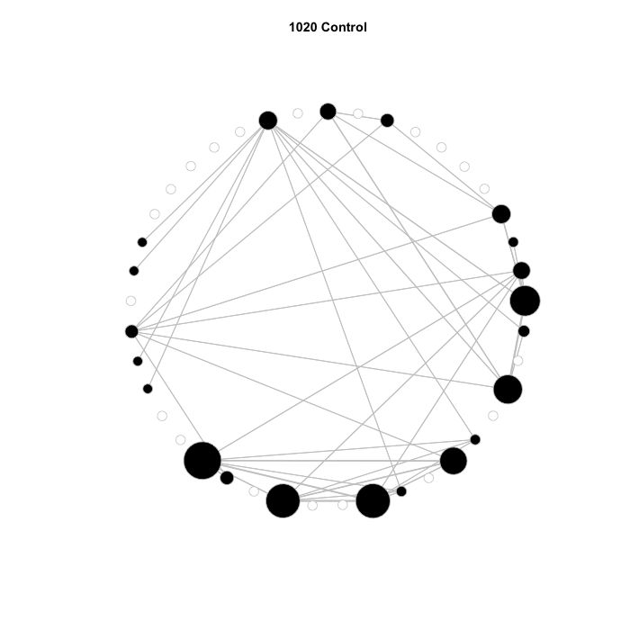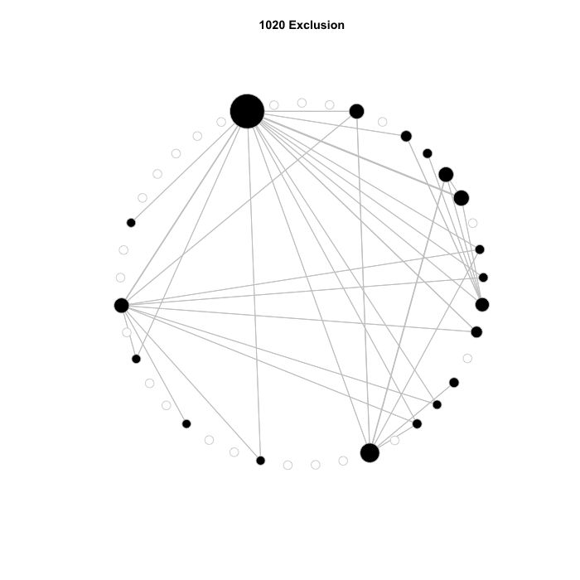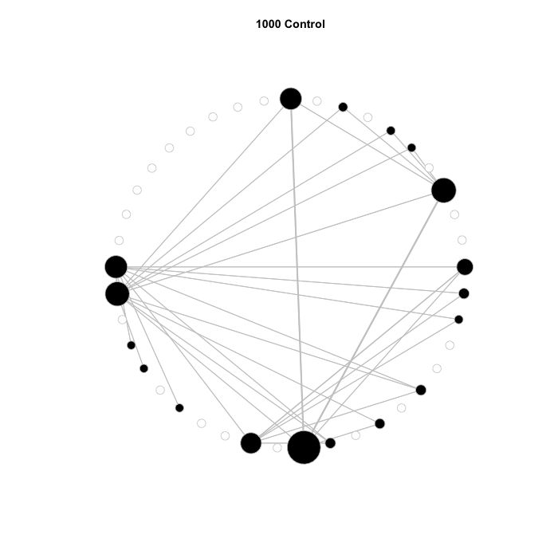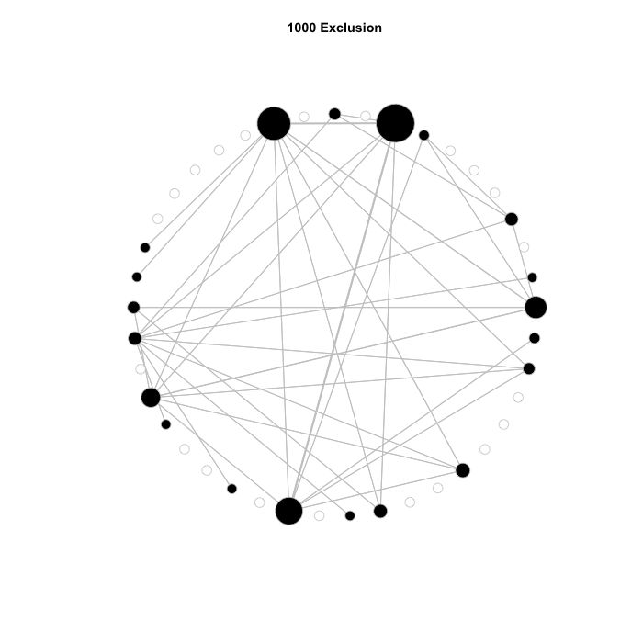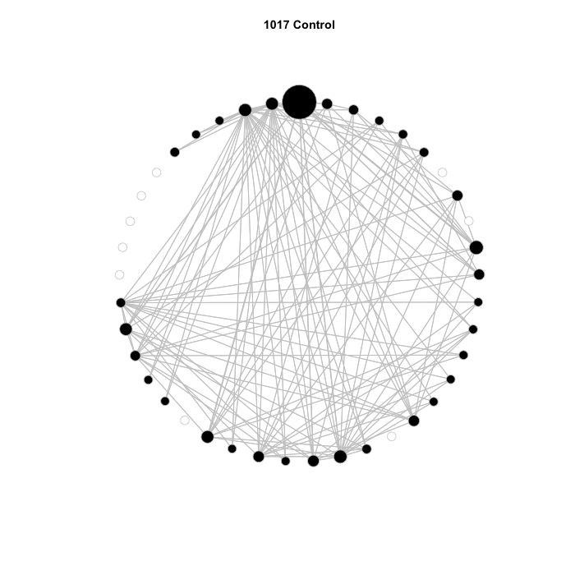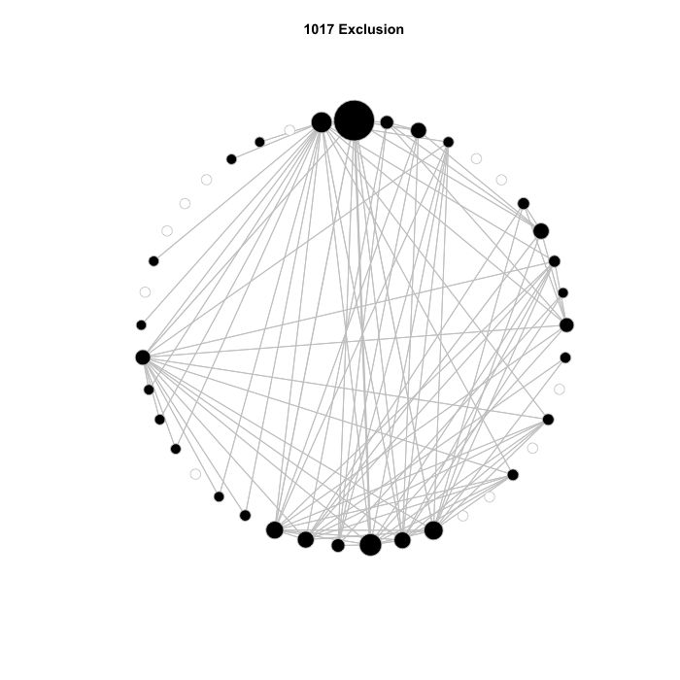

**Susceptible**

**Resistant**

**Aphid present**

**Aphid absent**

**More diversity**

**Less diversity**

**More stable**

**Less stable**

**Table of Arthropods:**